***FAKE NEWS DTECTION USING NLP***

***TEAM MEMBER***

***731721106016-Sangeetha.D***

***PHASE-5 PROJECT SUBMISSION***

***PROJECT: Fake News Detection***



***INTRODUCTION:***

* ***Fake news detection is a critical task in today's information age. It involves the identification and verification of misleading or fabricated information presented as factual news.***
* ***With the proliferation of social media and digital platforms, the spread of fake news has become a significant concern, impacting public discourse and decision-making.***
* ***In this context, advanced technologies, such as natural language processing and machine learning, play a vital role in developing tools and algorithms to detect and combat fake news effectively.***
* ***This is a challenging and evolving field that aims to safeguard the integrity of information and promote responsible journalism in the digital era.***

***OVERALL CONTENT OF OUR PROJECT:***

***Detecting fake news using Natural Language Processing (NLP) is a critical application to combat the spread of misinformation. Here's an overview of the process:***

***1. Data Collection: Gather a diverse dataset of news articles, including both real and fake news examples, preferably with labeled data for training.***

***2. Text Preprocessing: Clean and preprocess the text data by removing stop words, punctuation, and lowercasing the text. This step also includes tokenization and stemming or lemmatization.***

***3. Feature Extraction: Convert the preprocessed text into numerical features that NLP models can work with. Common techniques include TF-IDF (Term Frequency-Inverse Document Frequency) or word embeddings like Word2Vec or GloVe.***

***4. Model Selection: Choose an appropriate NLP model. Common choices are Recurrent Neural Networks (RNNs), Convolutional Neural Networks (CNNs), or more advanced models like Transformer-based architectures such as BERT, GPT, or RoBERTa.***

***5. Training: Train the chosen model using the labeled dataset. The model learns to distinguish between real and fake news based on the features extracted from the text.***

***6. Evaluation: Assess the model's performance using metrics such as accuracy, precision, recall, F1-score, and ROC AUC. Cross-validation can help ensure the model's robustness***

***7. Real-Time Detection: Deploy the model to detect fake news in real-time or batch processing. You can create a user-friendly application or integrate it into existing news platforms.***

***DATASET LINK:***

[**https://www.kaggle.com/datasets/clmentbisaillon/fake-and-real-news-dataset**](https://www.kaggle.com/datasets/clmentbisaillon/fake-and-real-news-dataset)

***TOOLS AND TECHNIQUES:***

***Detecting fake news using Natural Language Processing (NLP) involves various tools and techniques. Here are some key approaches:***

***1. Text Analysis and Sentiment Analysis:***

***- Analyzing the sentiment of the content can help identify biased or misleading information.***

***- Tools like NLTK, spaCy, or TextBlob can be useful for sentiment analysis.***

***2. Topic Modeling:***

***- Understanding the main topics within the content can help identify if the news is coherent and relevant.***

***- Latent Dirichlet Allocation (LDA) or Non-negative Matrix Factorization (NMF) are common topic modeling techniques.***

***3. Stance Detection:***

***- Determining the stance of the article towards a particular topic or event.***

***- This can be done using machine learning models trained on labeled datasets.***

***4. Fact-Checking Databases:***

***- Utilizing external fact-checking databases to verify the accuracy of claims made in the news.***

***- Websites like Snopes, FactCheck.org, or ClaimReview provide valuable resources.***

***5. Fake News Dataset for Training:***

***- Training machine learning models on datasets specifically designed for fake news detection.***

***- The Fake News Challenge dataset is an example.***

***SOURCE CODE LINK FOR PHASE-1:***

[***https://colab.research.google.com/drive/1wfnE3FxNxX6ZdACL6B_KpDGjm3_TwaeE?usp=sharing***](https://colab.research.google.com/drive/1wfnE3FxNxX6ZdACL6B_KpDGjm3_TwaeE?usp=sharing)

***PHASE-1:***

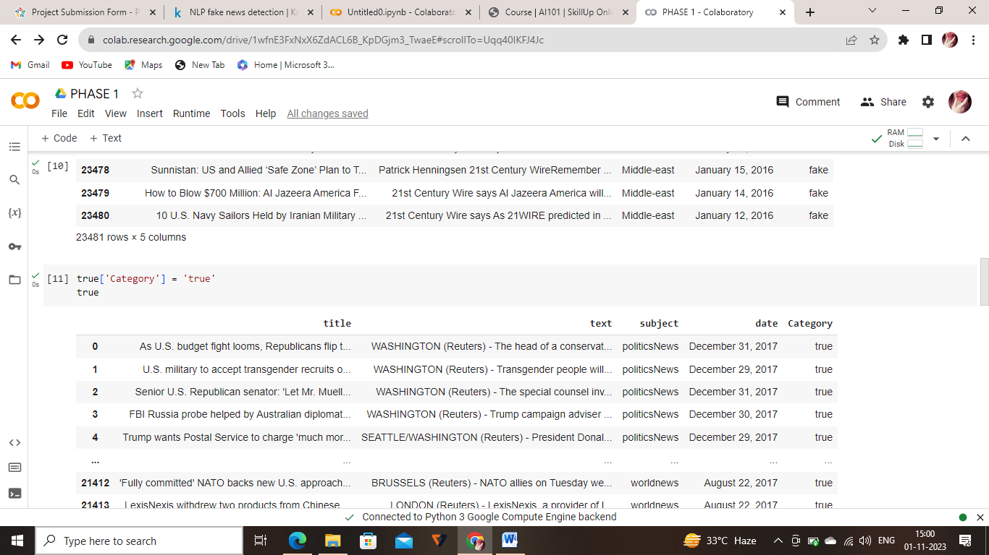

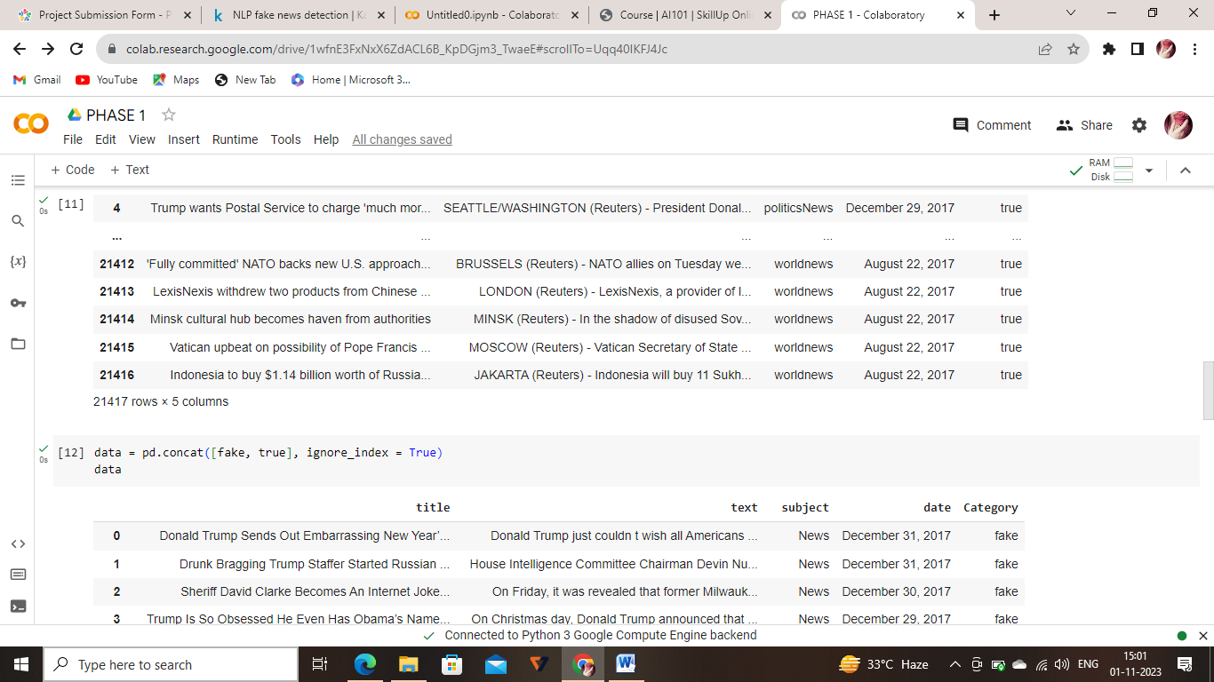

***SOURCE CODE FOR PHASE-2:***

[***https://colab.research.google.com/drive/15PiygXfYg7HuMUlC5iylFiJO5Q2coRjE?usp=sharing***](https://colab.research.google.com/drive/15PiygXfYg7HuMUlC5iylFiJO5Q2coRjE?usp=sharing)

***PHASE-2:***

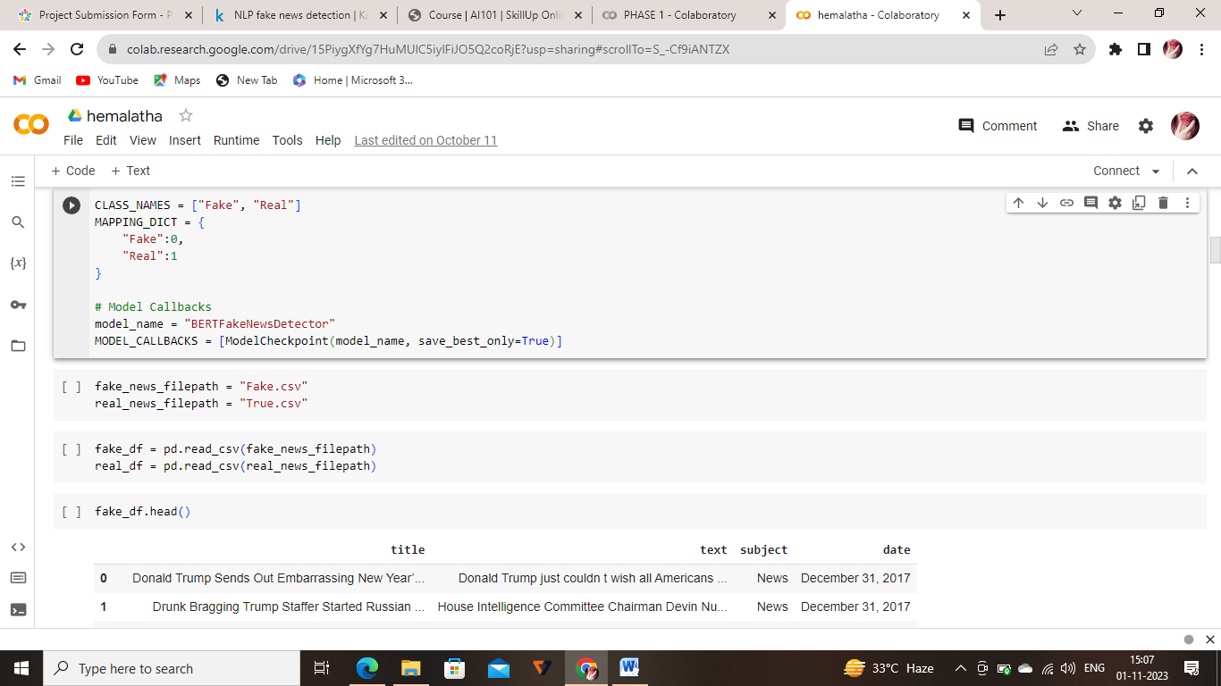

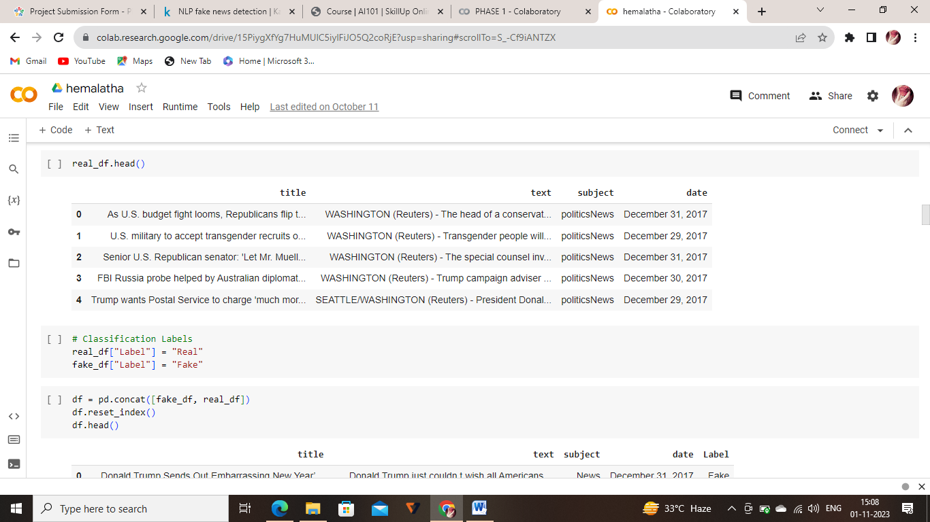

***SOURCE CODE LINK FOR PHASE-3:***

<https://colab.research.google.com/drive/1AUOG_lw3OgZwbsa1sFXwhRZYF-rQvMmo?usp=sharing>

***PHASE-3***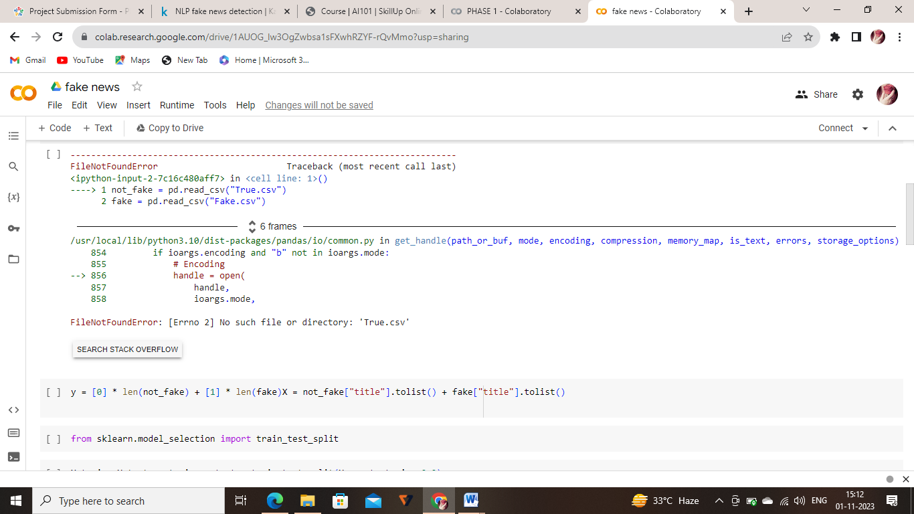

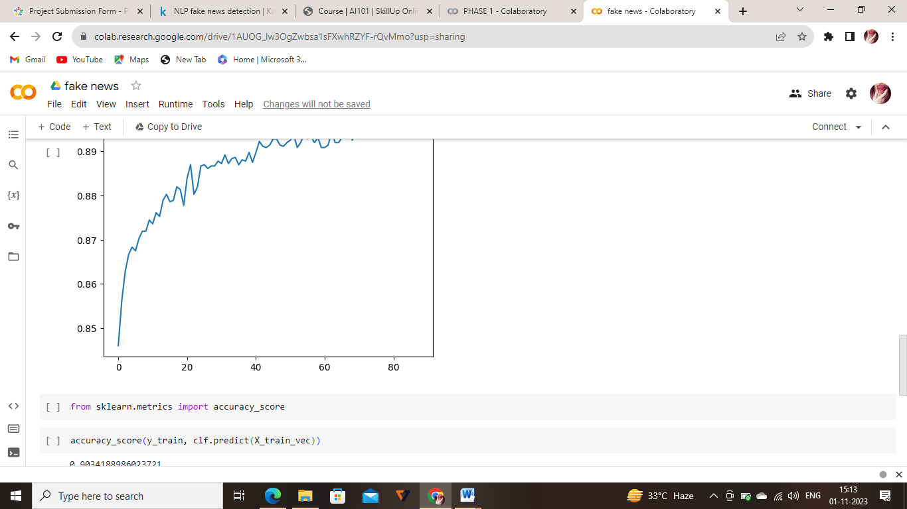

***SOURCE CODE LINK FOR PHASE-4:***

<https://colab.research.google.com/drive/1Y-vkaF9aA82-_AiOlaDTutNsF4qWFOOF#scrollTo=66zEsLXY-IxY&line=1&uniqifier=1>

***PHASE-4***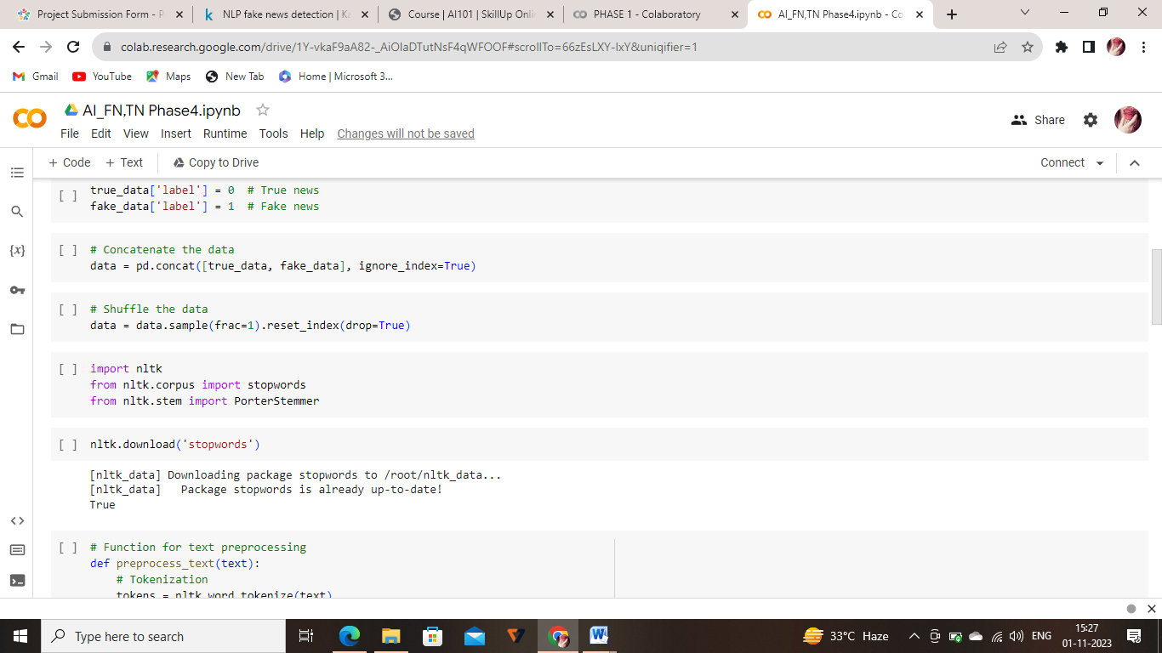

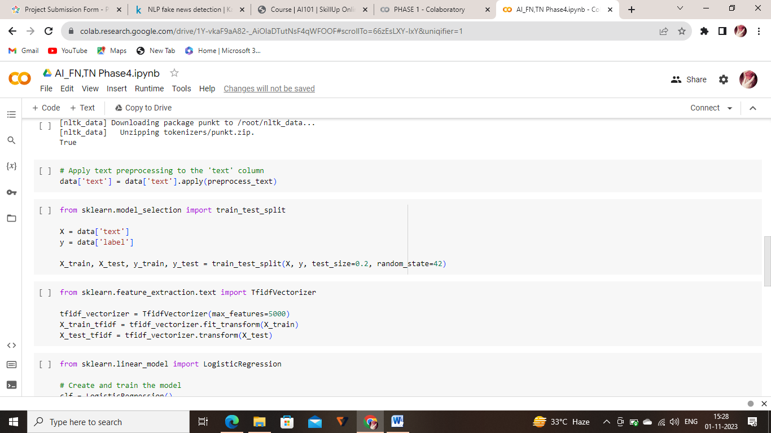

***ADVANTAGES:***

***1. Automated Analysis:NLP enables automated analysis of large volumes of text data, allowing for quick identification of potential fake news.***

***2. Real-time Detection: NLP algorithms can operate in real-time, providing swift identification of fake news as it emerges, helping curb its spread.***

***DISADVANTAGES:***

***1. Evading Techniques: Malicious actors can adapt and find ways to manipulate language to evade NLP-based detection methods, leading to potential false negative***

***BENEFITS:***

***1. Accuracy Improvement: NLP algorithms can analyze language patterns, sentiment, and context to distinguish between reliable and deceptive content, leading to more accurate news classification.***

***2. Timely Identification: NLP enables real-time analysis of large volumes of textual data, allowing for swift identification of fake news, which is crucial in the fast-paced nature of information dissemination.***

***3. Enhanced Trustworthiness: By filtering out fake news, NLP contributes to the credibility of news sources, fostering trust among consumers and reducing the spread of misinformation.***

***4. Automation: NLP allows for automated monitoring of news content, saving time and resources compared to manual fact-checking processes. This is especially important considering the vast amount of information available online.***